Our Design Document

**Description:**

Learning with Felix Cobbold: Christchurch Mansion is a short educational game designed to be played while visiting the Christchurch Mansion or after a visit. The game will be a compilation of minigames designed to test the knowledge learning in the mansion, designed to be played quickly in order to not take away from the mansion itself. Each minigame will be based around a room of the mansion and will test knowledge that can be gained in that room.

**Story and Character**

Felix Cobbold is the man who had gifted the Mansion to the town of Ipswich. In the concept we have come up with, we will have a digital companion that will act as an intermediary for the Christchurch mansion and it’s exhibits. He will be an intermediary, not a tour guide and he would be fitting for the role as he is the reason why the Christchurch Mansion is with us today.

The story of our game is that Felix Cobbold is the lens to the past for the visitors. As they go through the mansion, in different rooms Felix will allow them to learn something more or take more out of the exhibit.

For an example story, Felix introduces himself and the visitors begin in The Great Hall. They click on that part on the map. There is a man (a bouncer) who tells them they cannot pass through as the visitors are not dressed in the proper attire. So, then Felix Cobbold helps the visitor and tells them to dress up. Using the paintings on the wall as references, the visitor must choose correctly the outfits for the mannequin to have the correct 1890s attire. When the visitor submits the outfit they have chosen, the man (a bouncer) will let them right through unlocking another room, ready for the visitors to go into and play.   
  
This was how we are planning to go about the rooms that we have chosen. In a way it is like bringing the artefacts around you to life, making the visitors be more aware of the smaller details of the exhibits. The kind of emotions we want from visitors is like the “ahh” or and “ohhhh, so that’s why” moments. We want to make them be more intrigued, interested and curious.

**Gameplay**

The game will feature 4 unique minigames based off rooms on the first floor of the Mansion, new minigames for the second floor and elsewhere in the mansion could be added post release. The goal of the game is to complete these minigames to advance to more minigames, we also intend to eventually add a badge room where players can keep track of their completed minigames in order to add a completion element. The skills this game will focus on is players memory and research skills as the focus of the game is testing the players knowledge. The gameplay will involve the player tapping buttons on a touch screen, what these buttons do will depend on the minigame. The buttons may be used to switch between different outfits in one minigame or to organize a timeline in another.

**Art style**

The art style we are going for is paper craft/storybook mixed with cel shaded.

We are using these types of art styles because they allow us to use the photographs, we have taken of the mansion interior and modify them to better suit our style, without having to create more assets from scratch.

This is useful because it is easier for us and for the visitors to understand what they are visually looking at; the visitors can easily connect a portrait and a cel shaded version of that portrait rather than an asset made in a significantly different style.

The paper craft art style helps to make it for a wider variety of audiences, and it helps with our timeframe.

Mood boards of art style below:

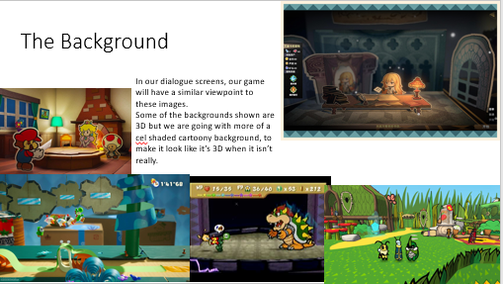 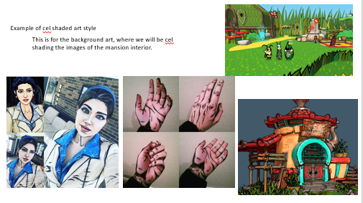

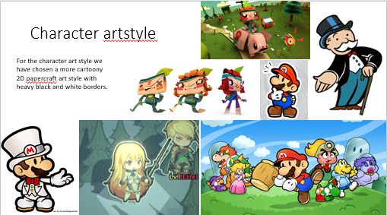

**Technical Details**

The game will be developed for Android but will be ported to iOS later if the game is successful

The game will be developed in Unreal Engine 4

Art will be created in Photoshop

**Demographics and platform**

The Demographic for our concept game is targeted at young people between the ages of 14-25 years old and families. This is because that is what the exhibitions demographic are.

The platform we are using to make the concept game is on Unreal Engine 4.

The platform we are using to release our game is an app on the iPad provided in the mansion or an offline Android app that visitors can download on their mobile devices.

**Development Challenges**

It may be challenging to initiate a proper emotional response while keeping game focused on education.

Neither group member has created a game designed for gameplay on a touchscreen before and thus it is an unknown challenge.

It may be difficult to get players to sufficiently interact with both the game and the mansion without one overshadowing the other in terms of enjoyment.

Neither group member has published a game on a mobile storefront before and we may find it challenging to do so.

Due to the circumstances regarding the playtesting of this game, (young target audience, play testers need to have visited the museum). It may become difficult to find valid playtests and in turn playtesting data.